**LINUX:**

**Q**.2

1.Created a new directory with name demo.sh using “mkdir” command

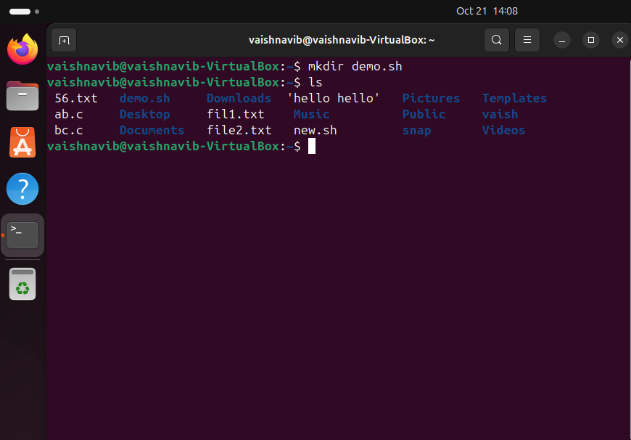

2. In this step existing directory is rename with new name using “mv” command

Write a shell script that take three numbers as user input and display the smallest number and the average of three numbrers and calculate the sum of square of each three numbers.

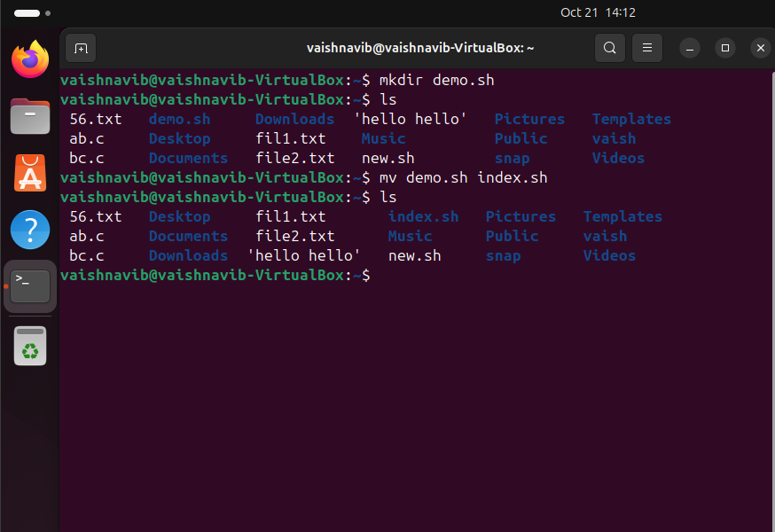

3.In this step new directory is created using “mkdir” command and then existing directory move in the new directory i.e. to another location .

List of directory/file can see by “ls” command

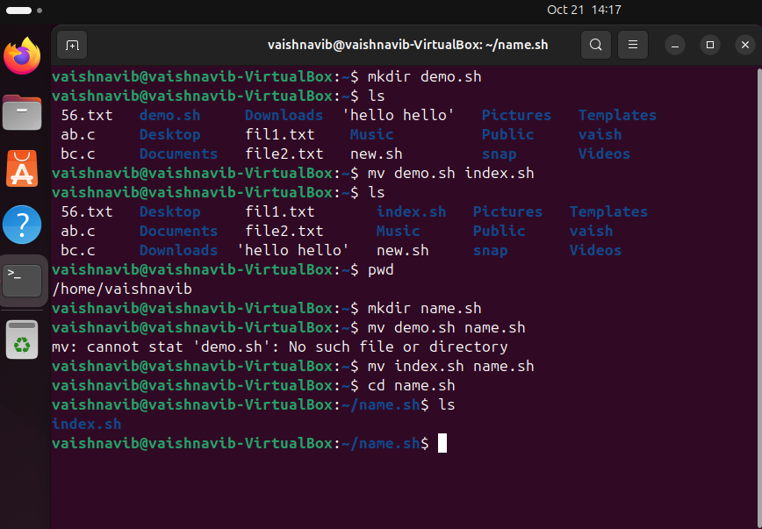

4.Existing file is deleted using rm -r command

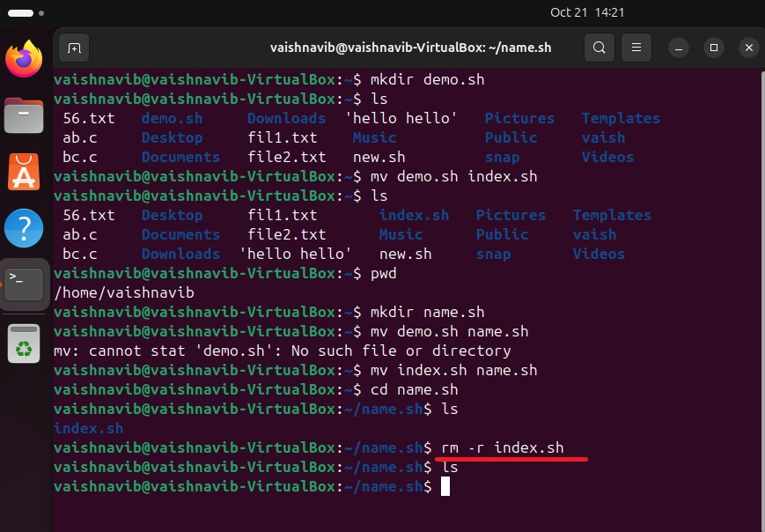

5.New file is created using “touch” command and then permission is given to the user and group using “chmod u=rw,g=rw,o=- file1.txt”

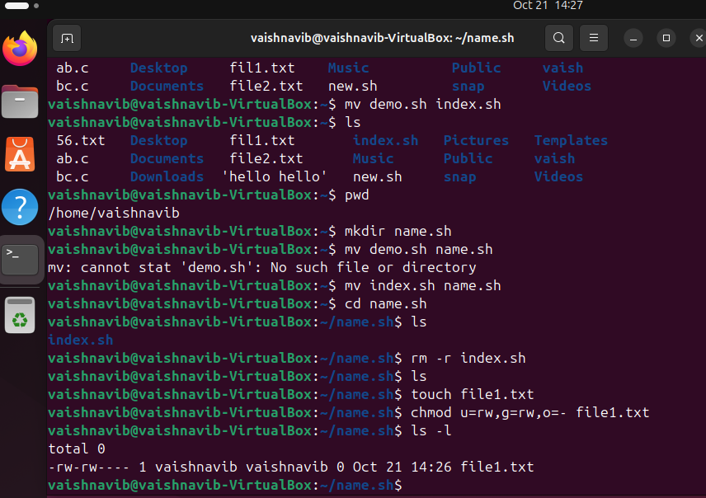

Q.1

1.Code: echo Enter the first number

read num1

echo Enter the second number

read num2

echo Enter the third number

read num3

if [ $num1 -le $num2 ] && [ $num1 -le $num3 ]; then

smallest=$num1

elif [ $num2 -le $num1 ] && [ $num2 -le $num3 ]; then

smallest=$num2

else

smallest=$num3

fi

echo "Smallest number: $smallest"

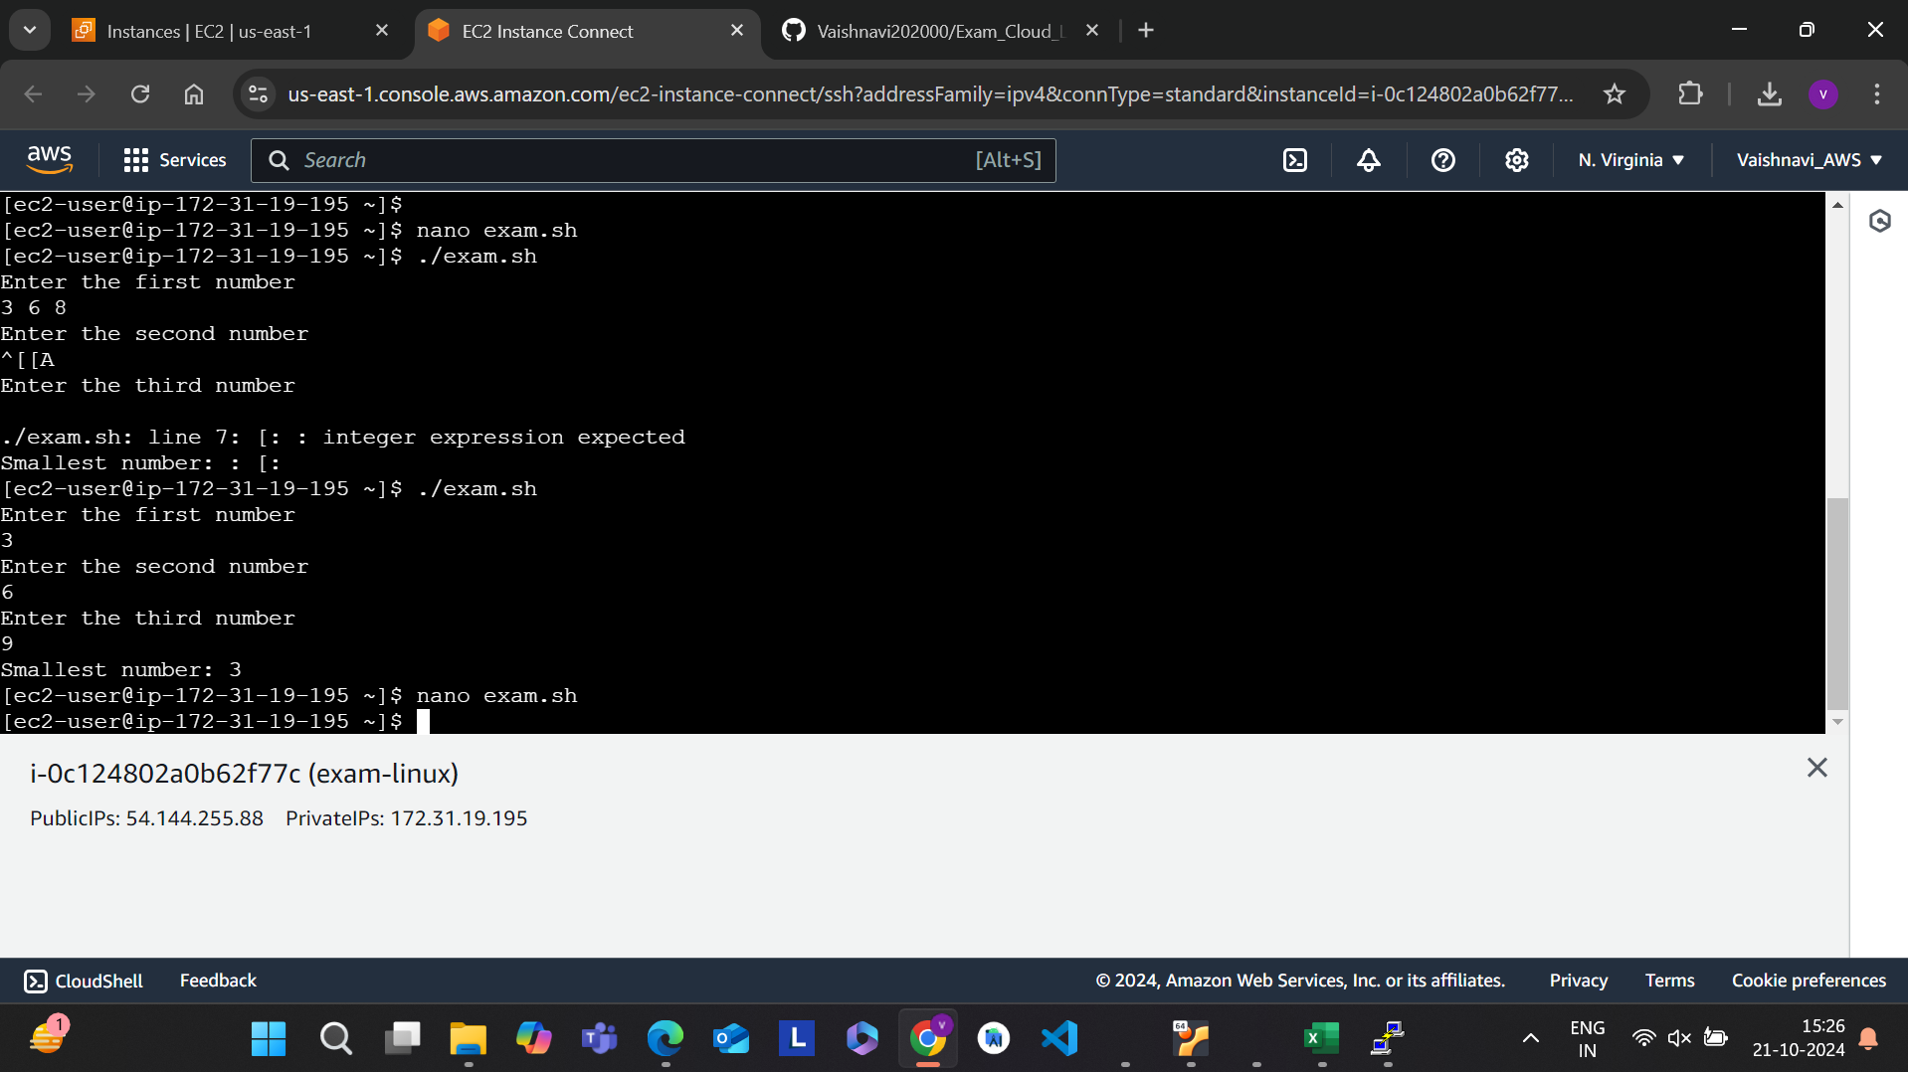

2.Code: echo Enter the first number

read num1

echo Enter the second number

read num2

echo Enter the third number

read num3

average=$(echo "scale=2; ($num1 + $num2 + $num3) / 3" | bc)

echo "Average: $average"

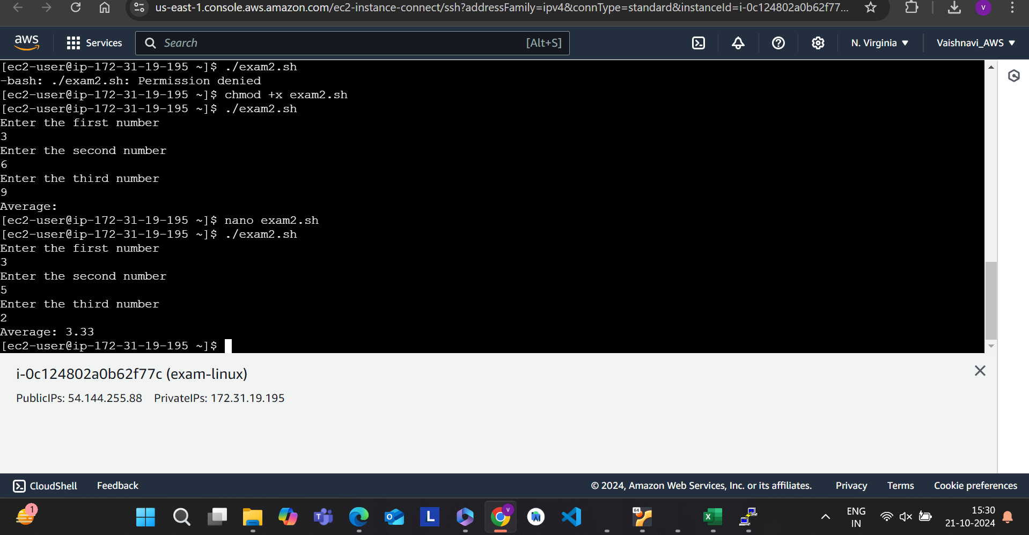

3.code: echo Enter the first number

read num1

echo Enter the second number

read num2

echo Enter the third number

read num3

sum_of_squares=$(echo "$num1*$num1 + $num2*$num2 + $num3*$num3" | bc)

echo "Sum of squares: $sum_of_squares"

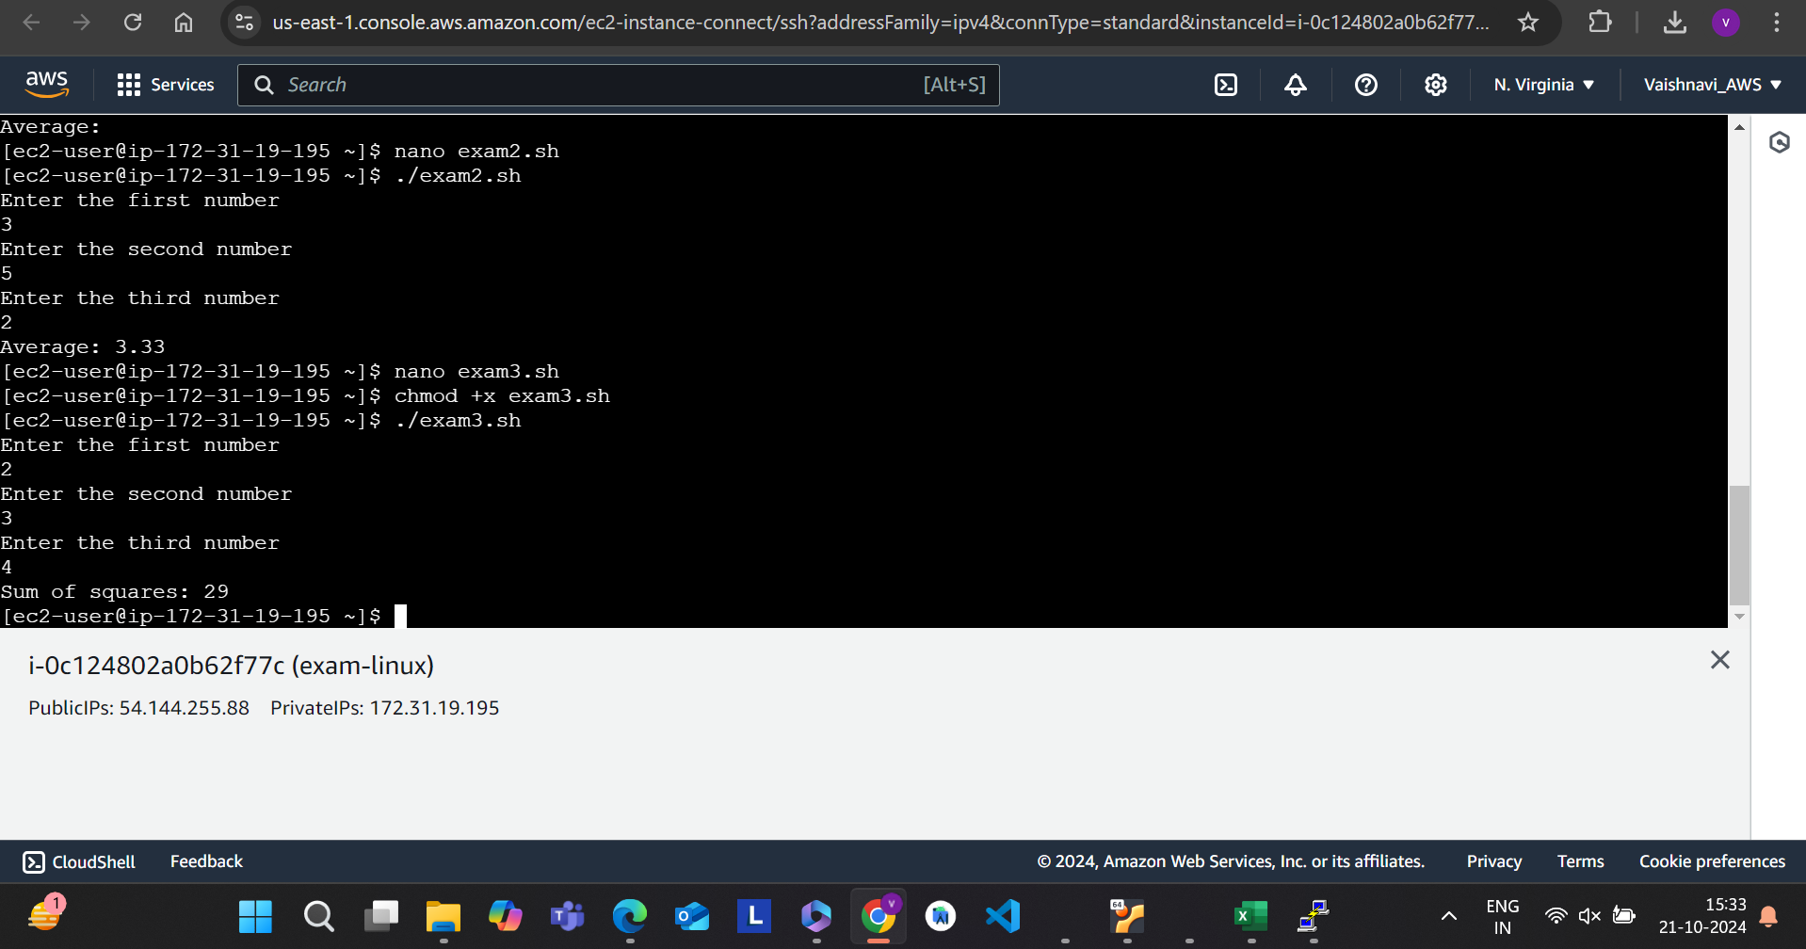

**CLOUD:**

**Step 1**: Login to AWS and search IAM in services

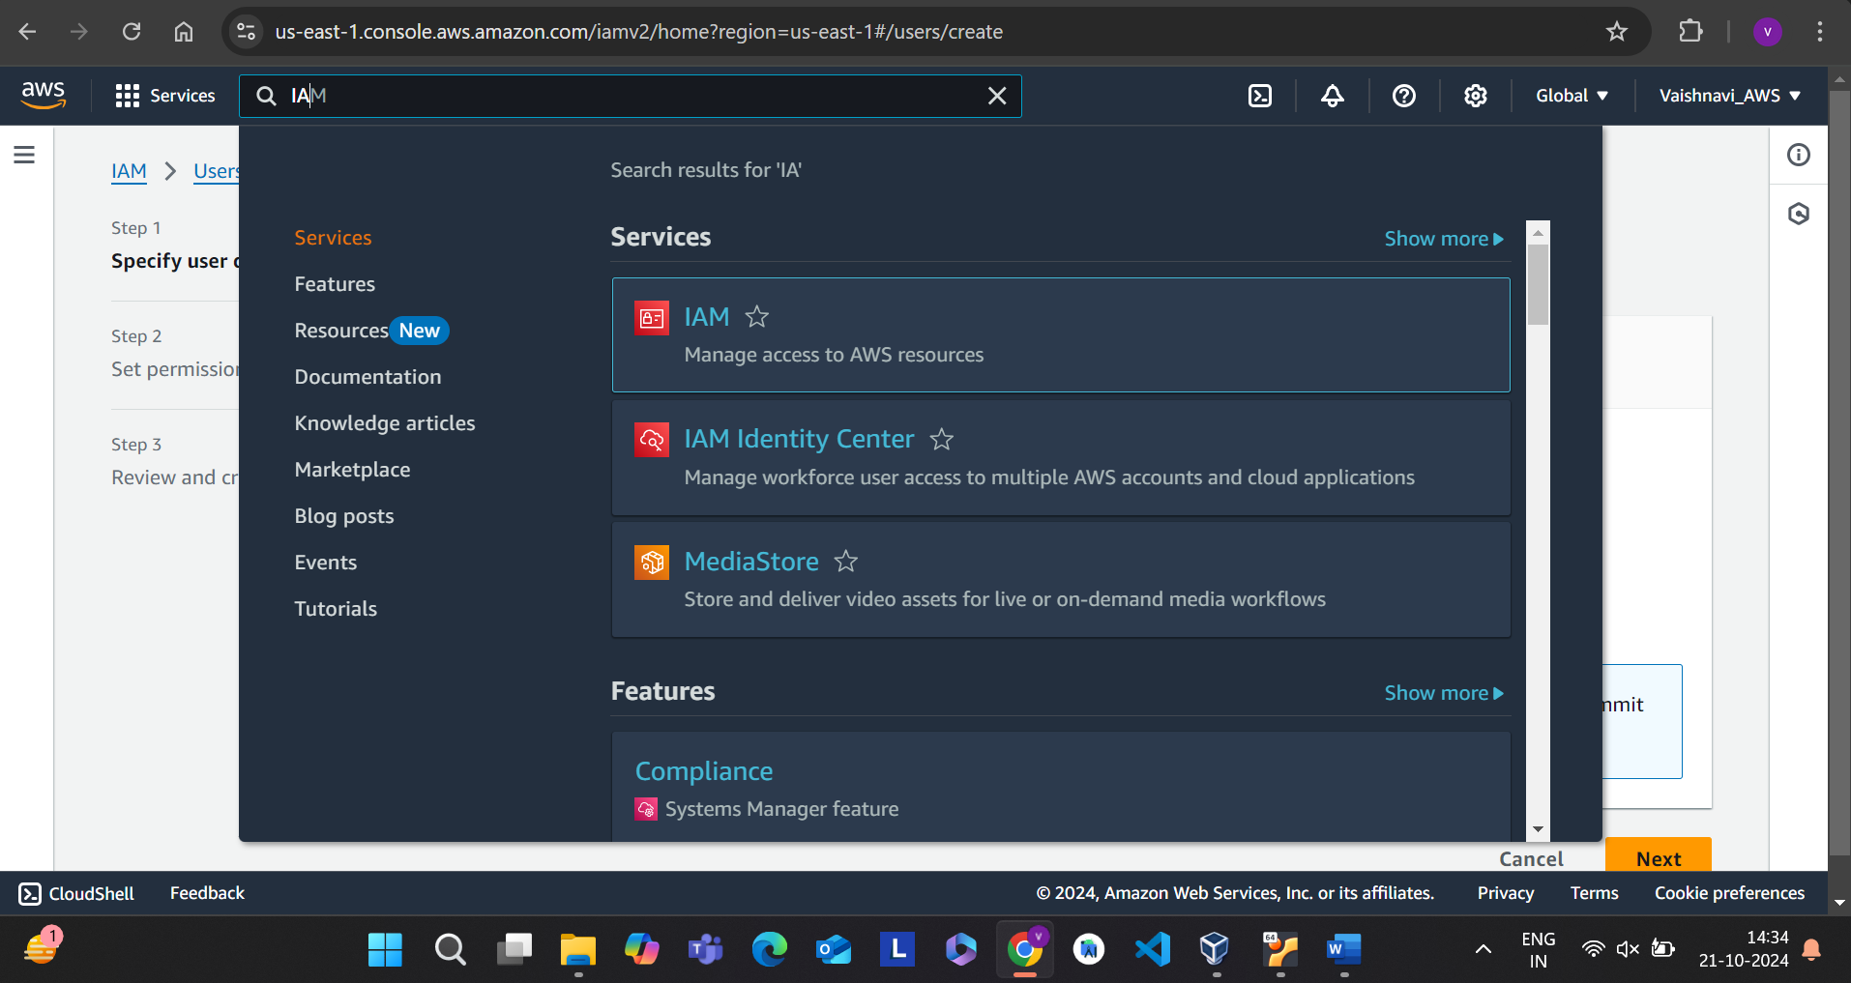

**Step 2:** Go to user and click on create user.

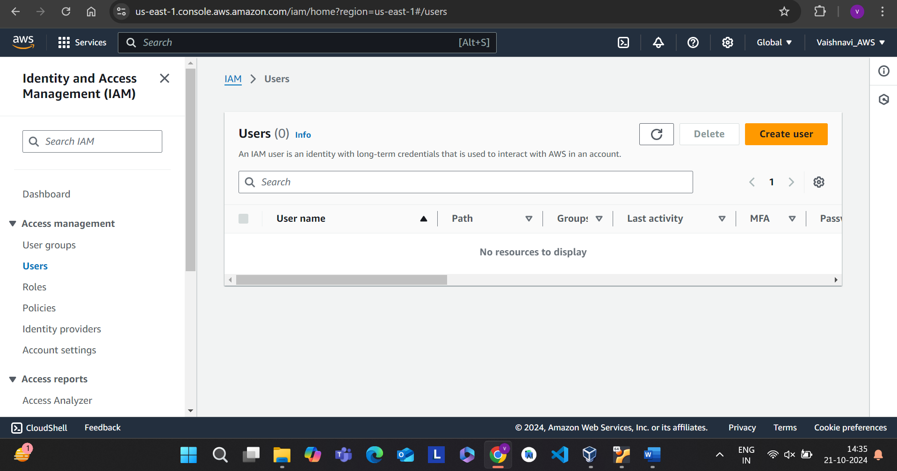

**Step 3:** Enter the user name and click on next

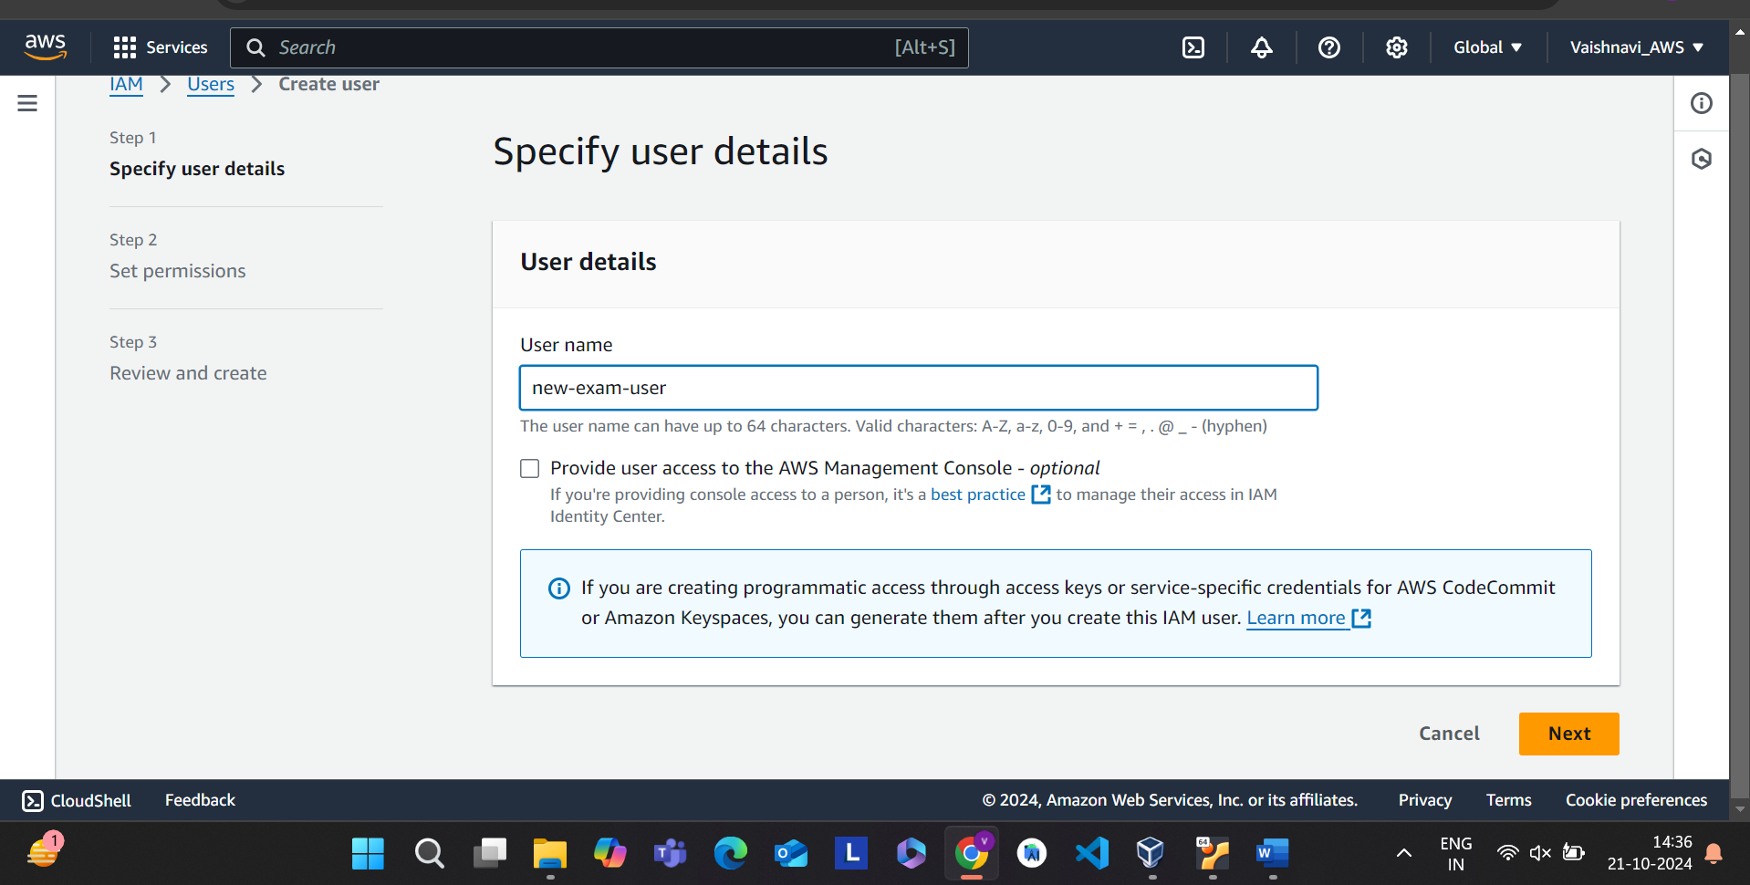

**Step 4**: Click on attach policies directly and then go to create policy.

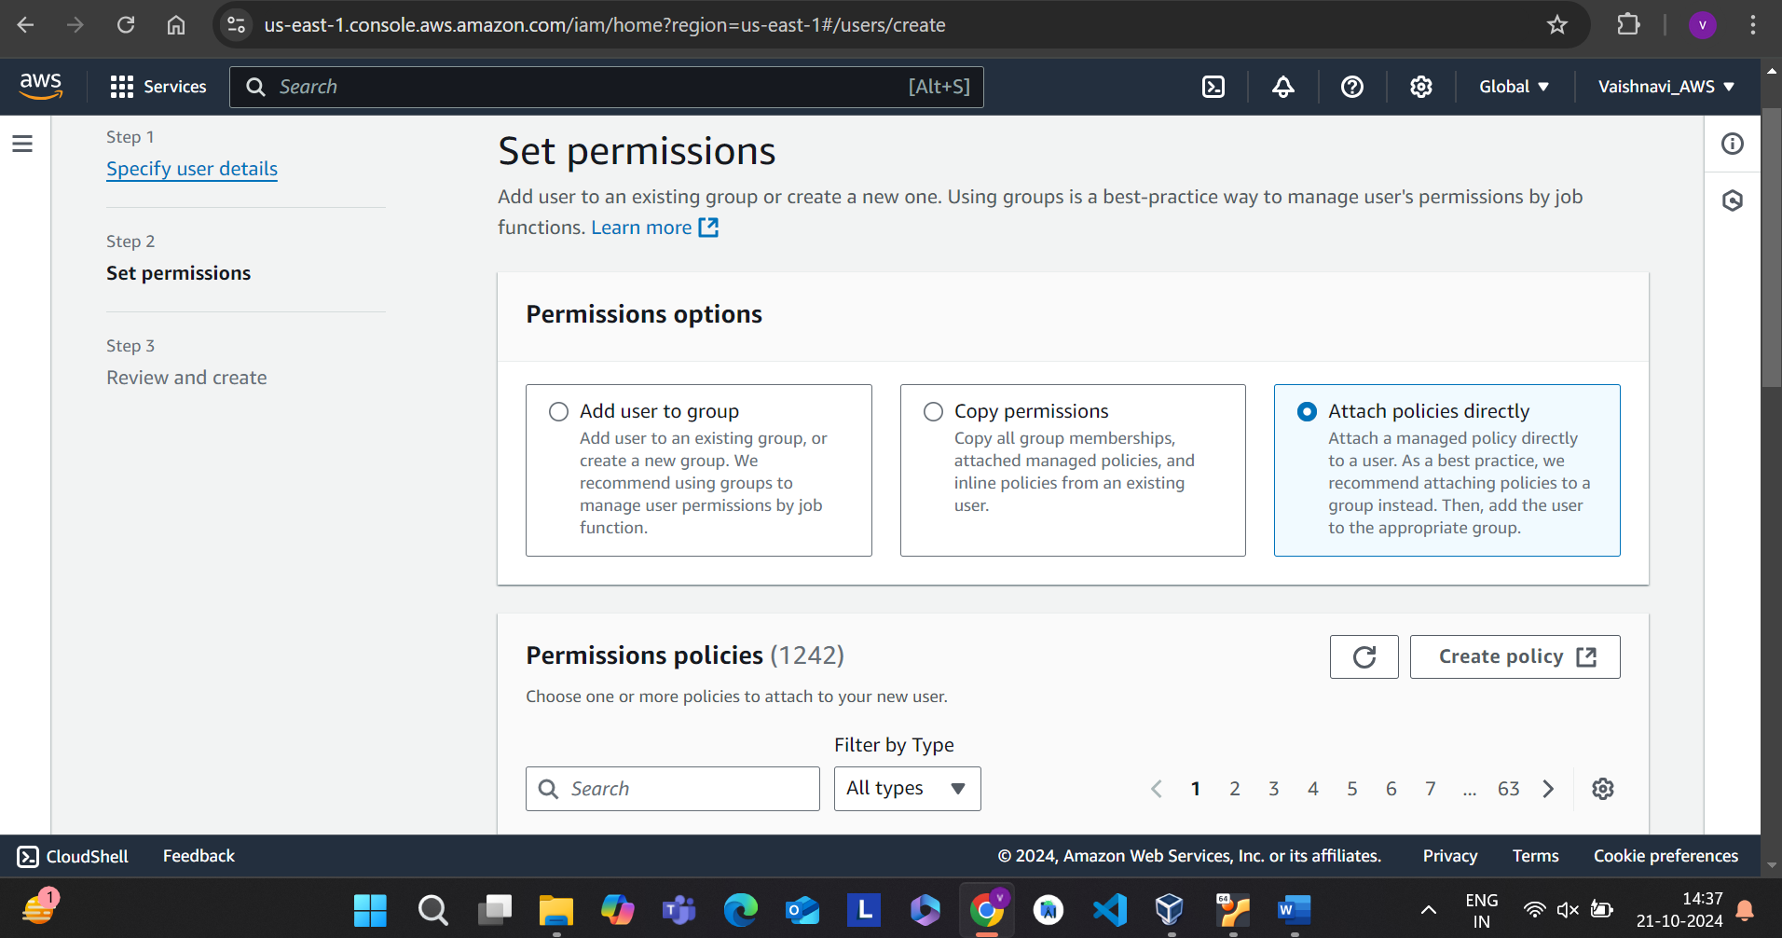

**Step 5**: Then search policy ECf2FullAccess and go to next.

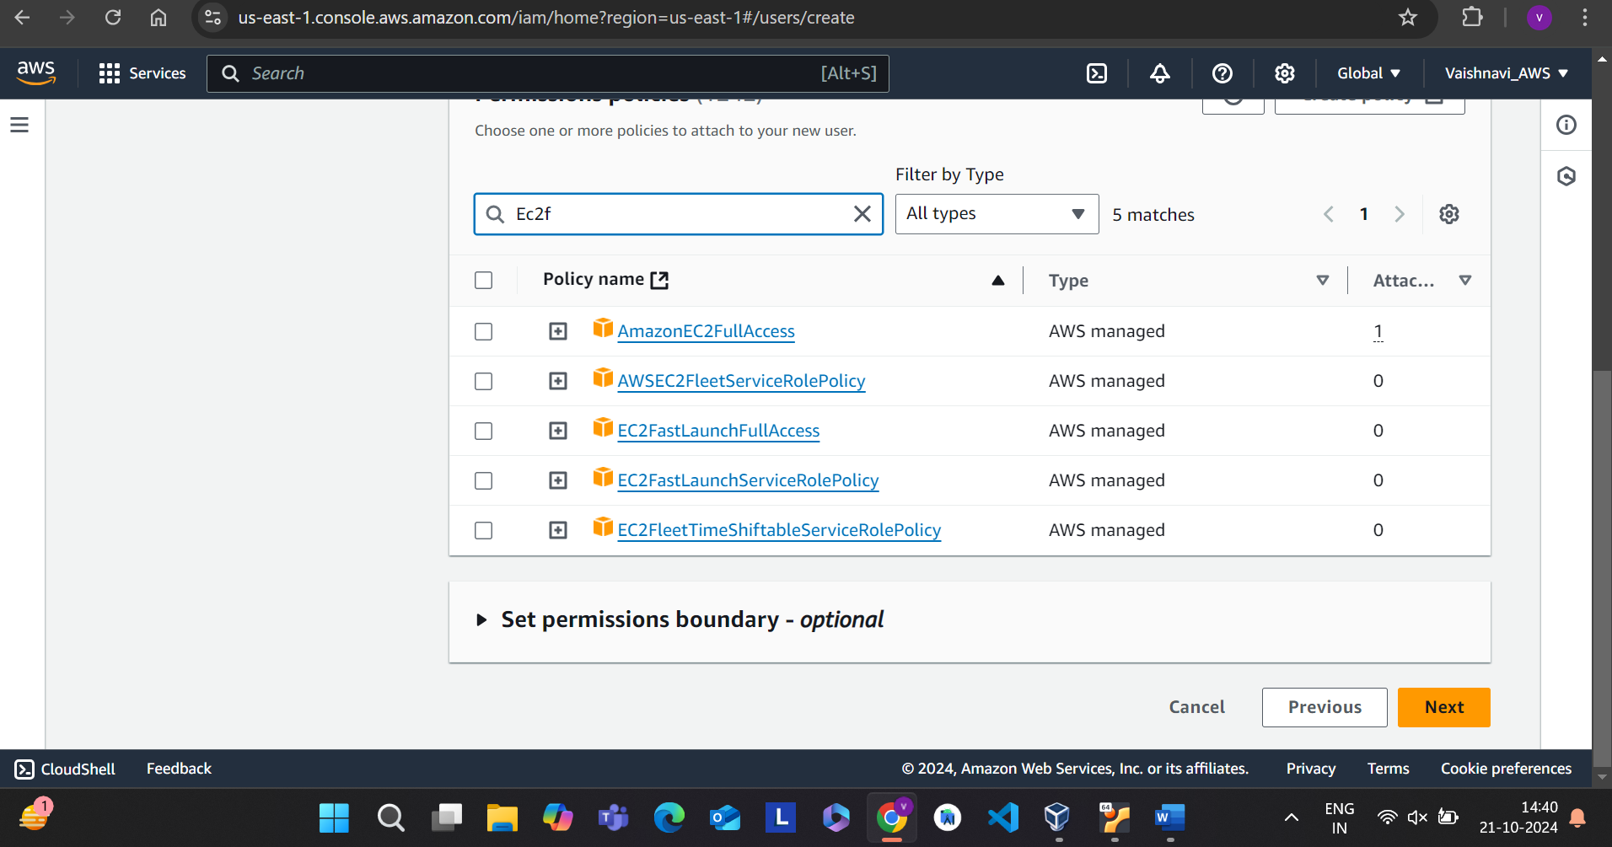

**Step 6**: Then click on create user.

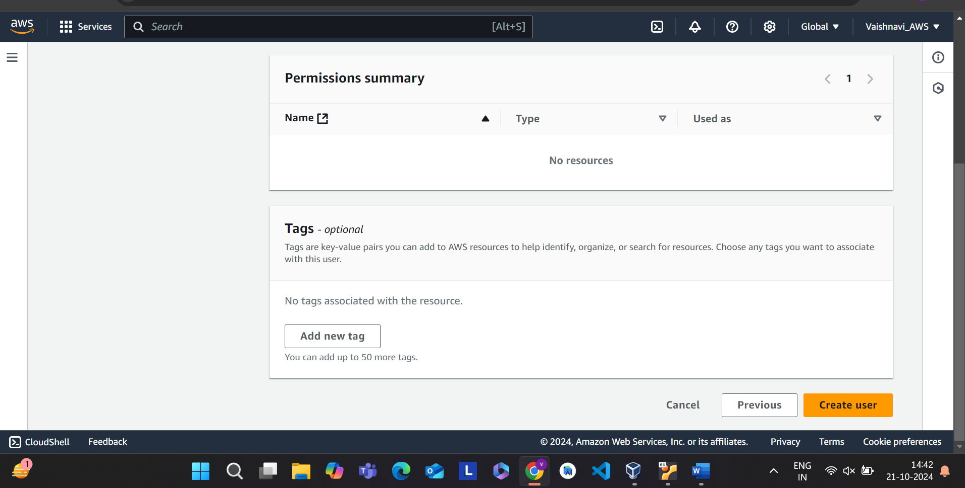

**Step 7:** IAM user is created successfully.

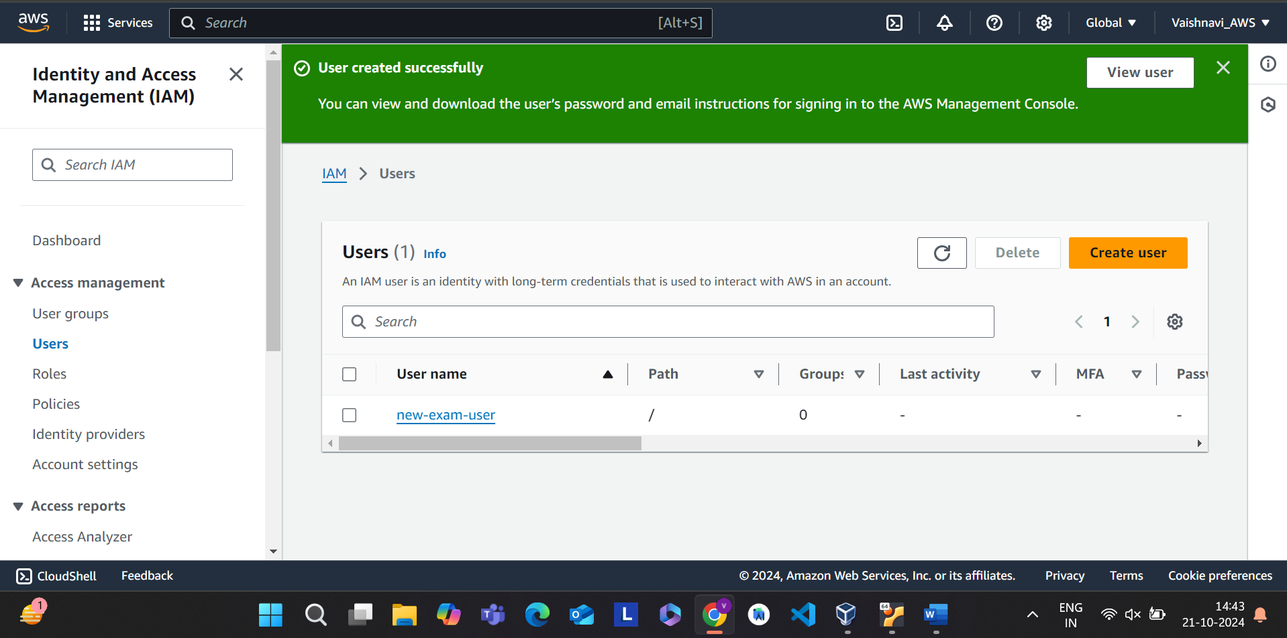

**Step 1**: Click on the user that you created.

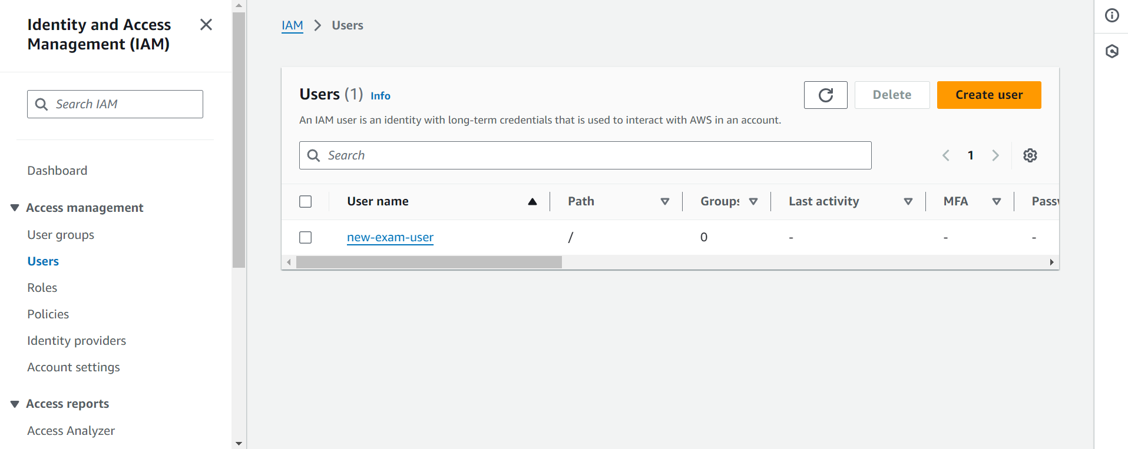

**Step 2:** Then click on create access key.

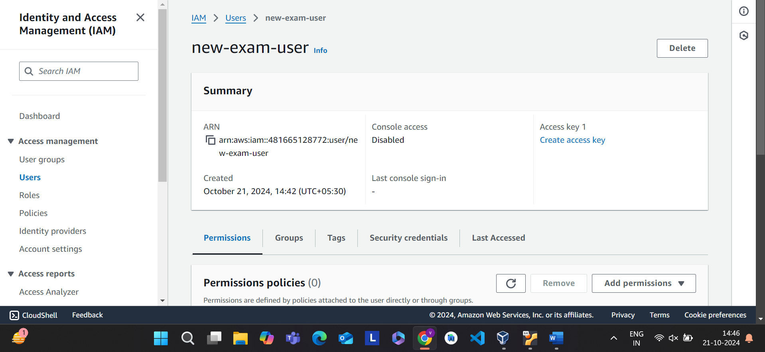

**Step 3:** Select Application running on an AWS compute service option.

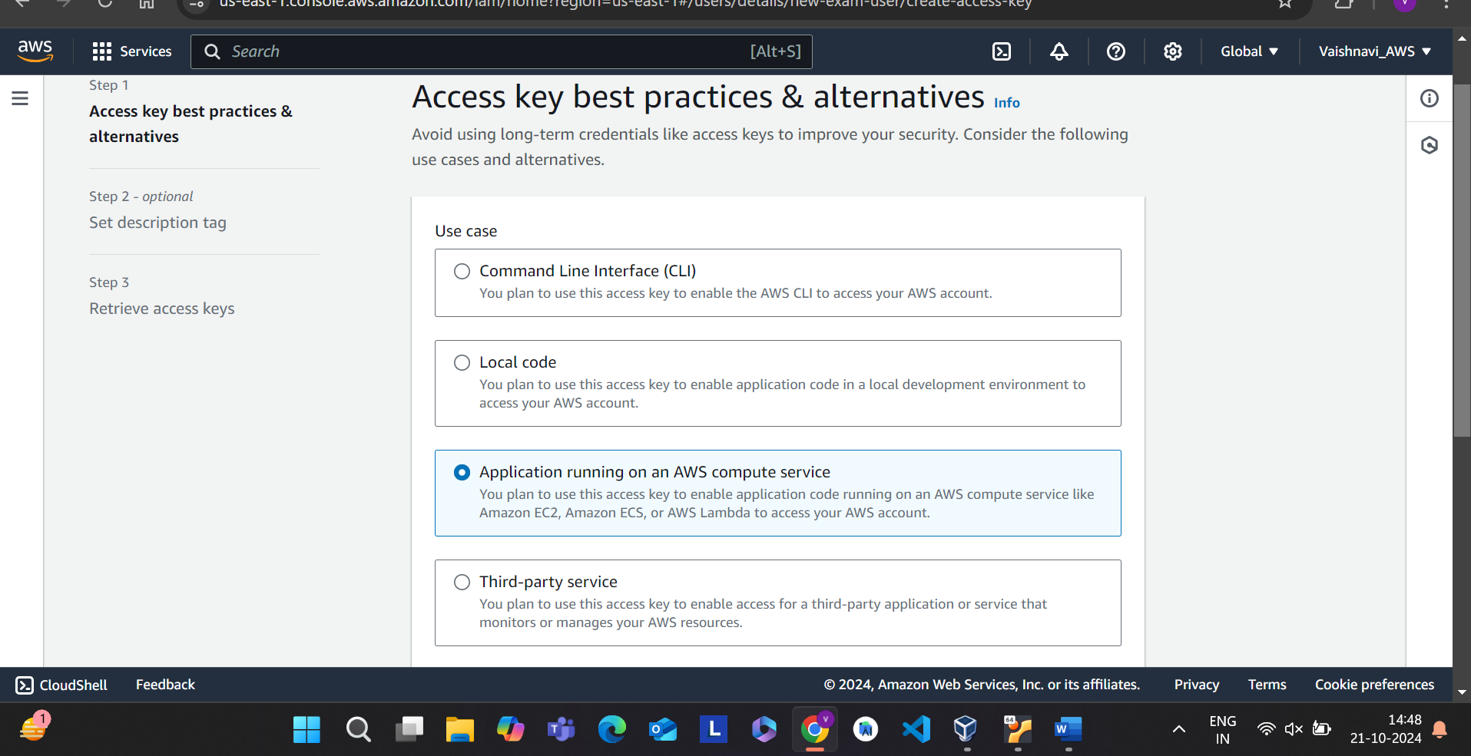

**Step 4:** Then click on next.

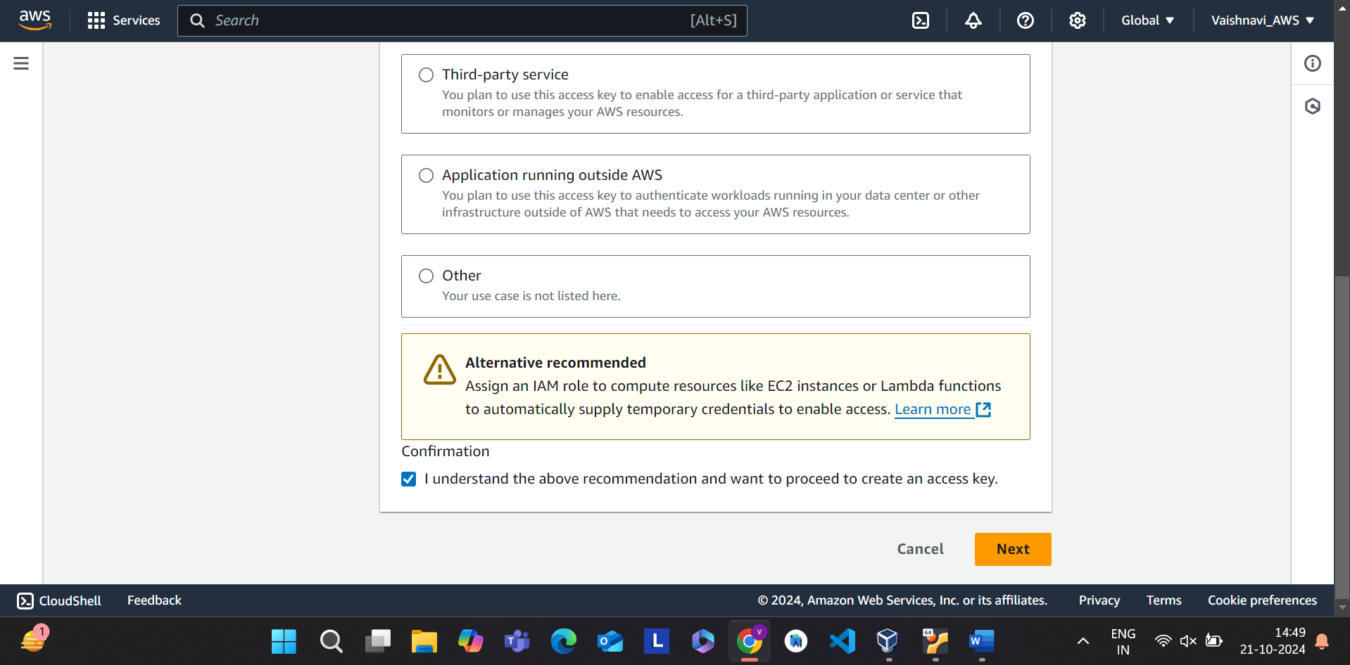

**Step 5**: Enter the tag and Click on create access key.

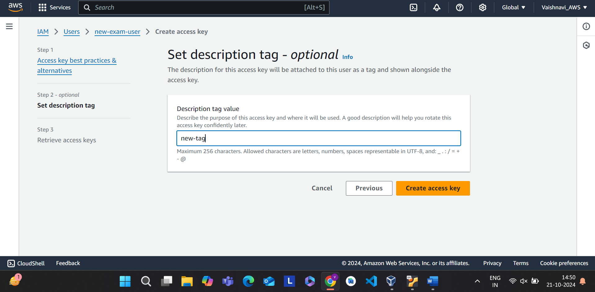

**Step 6:** Copy access key id and secret key or download csv file. Then click on done.

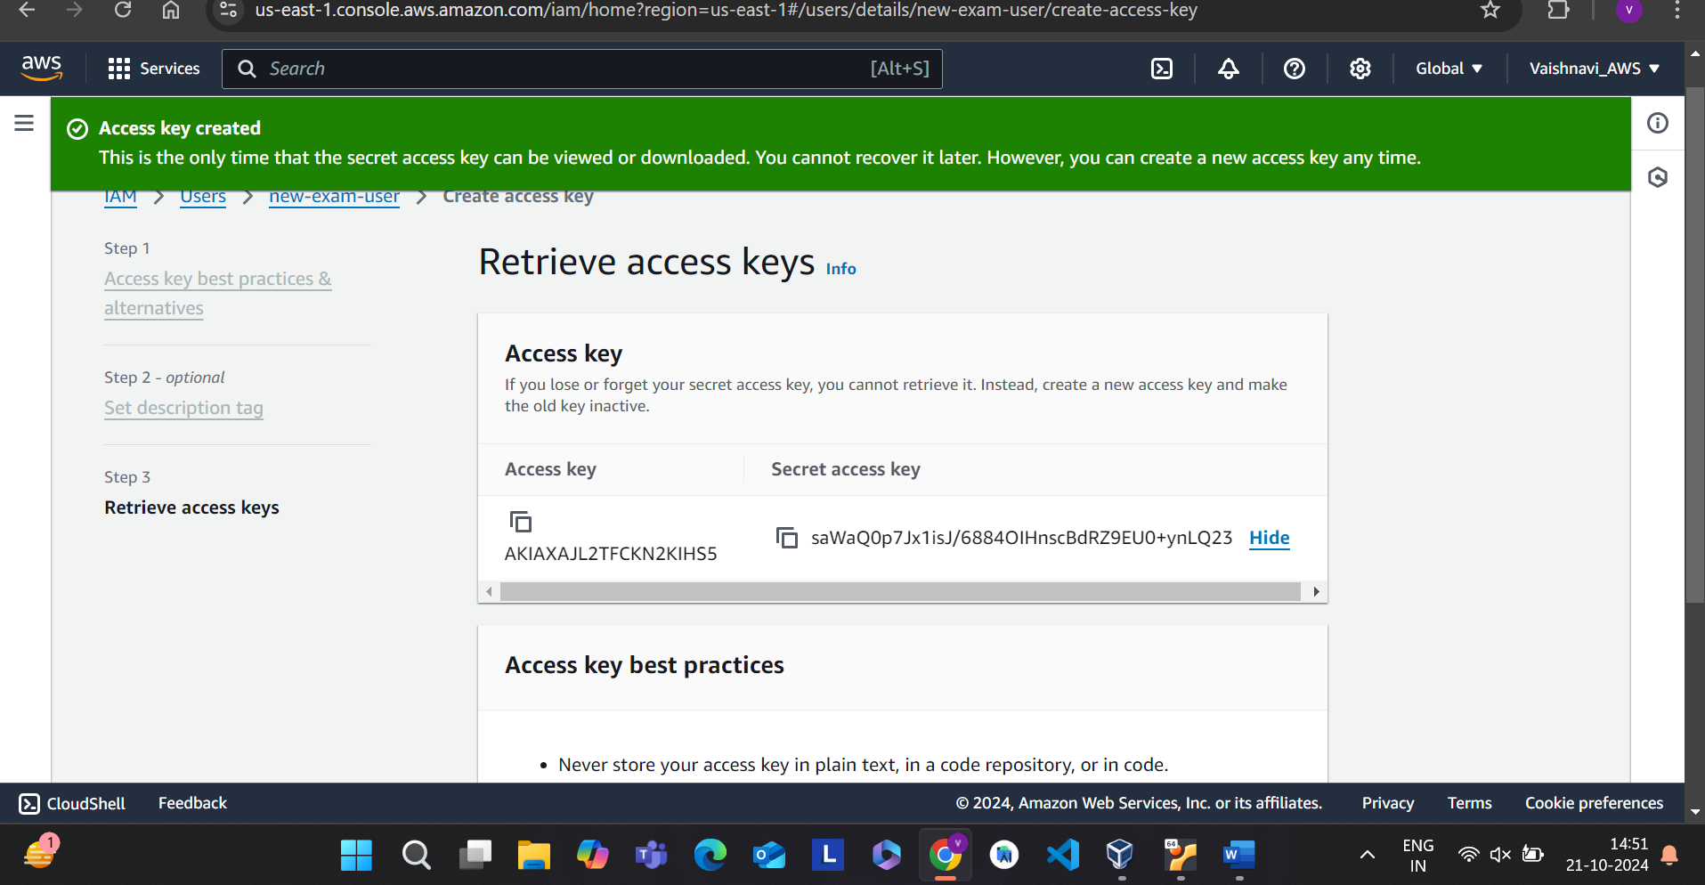

**Step 7: Then go to security creandentials and click on enable console access.**

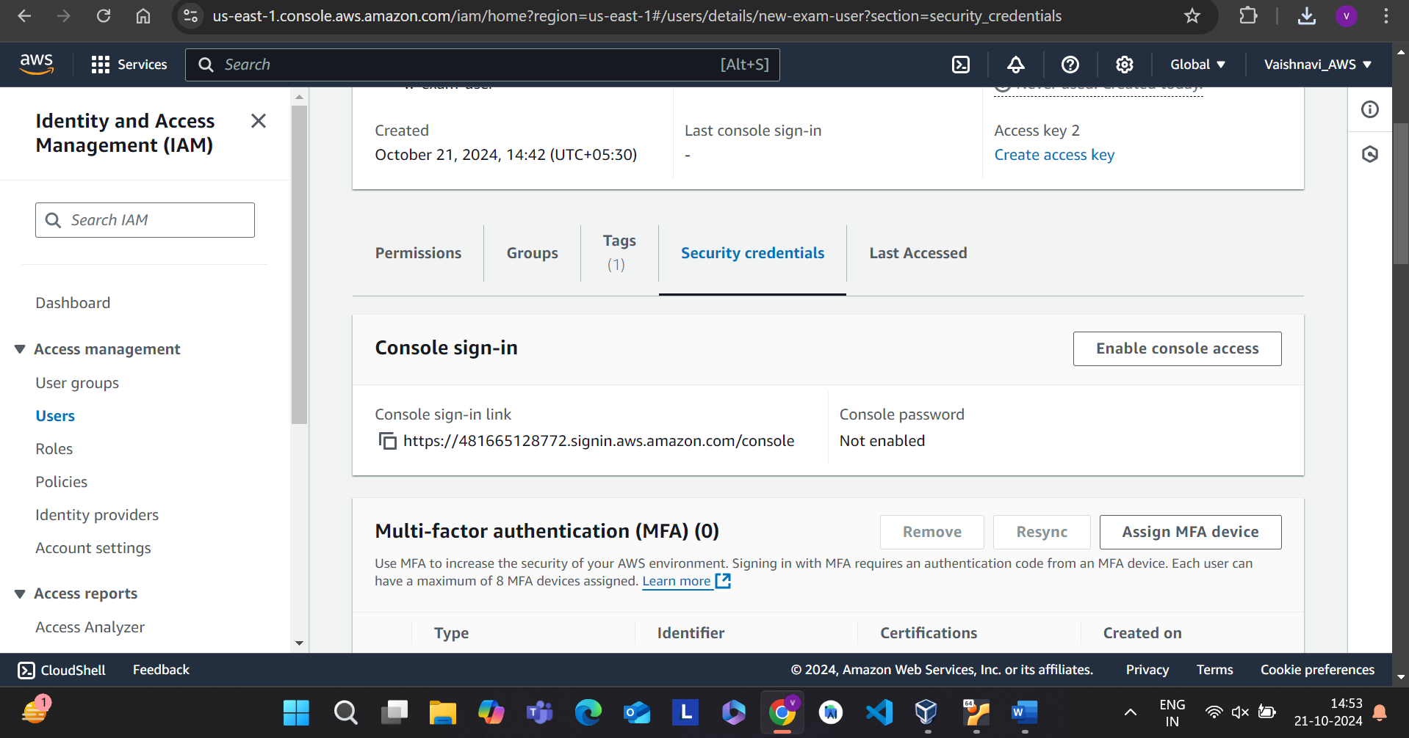

**Step 8: Select auto-generated password and then click on enable console access.**

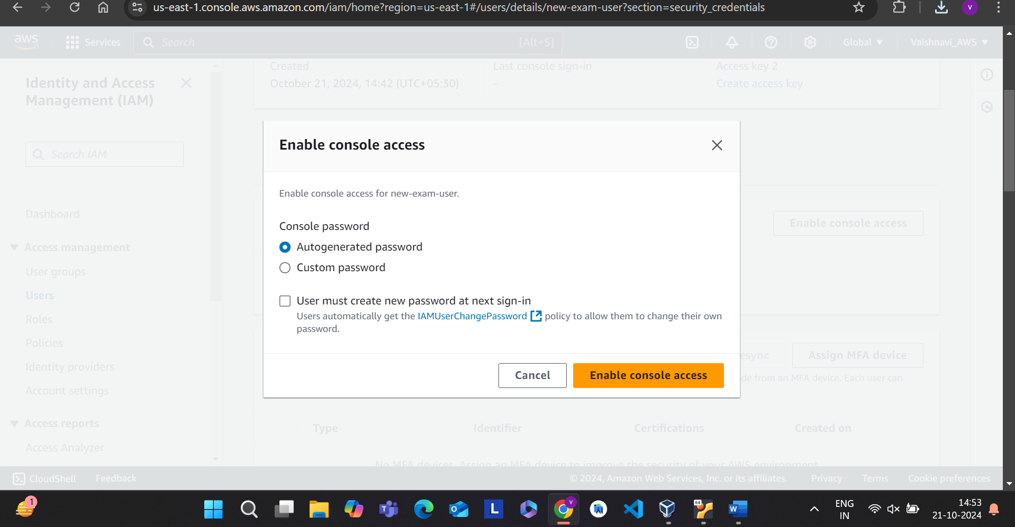

**Step 9: Then download csv file and close that.**

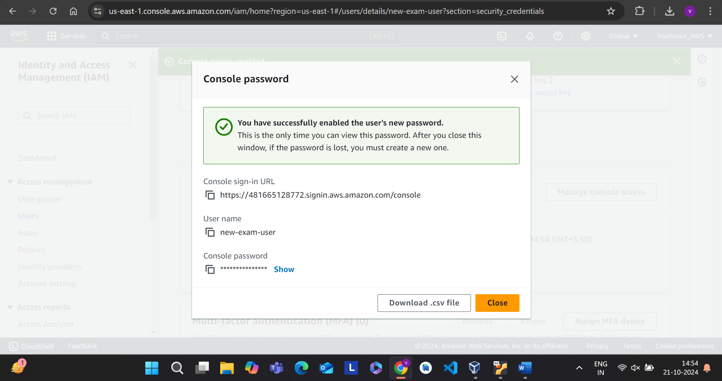

**Step 10:** Login with the credentials present in the csv file.Enter username and password and click on sign in.

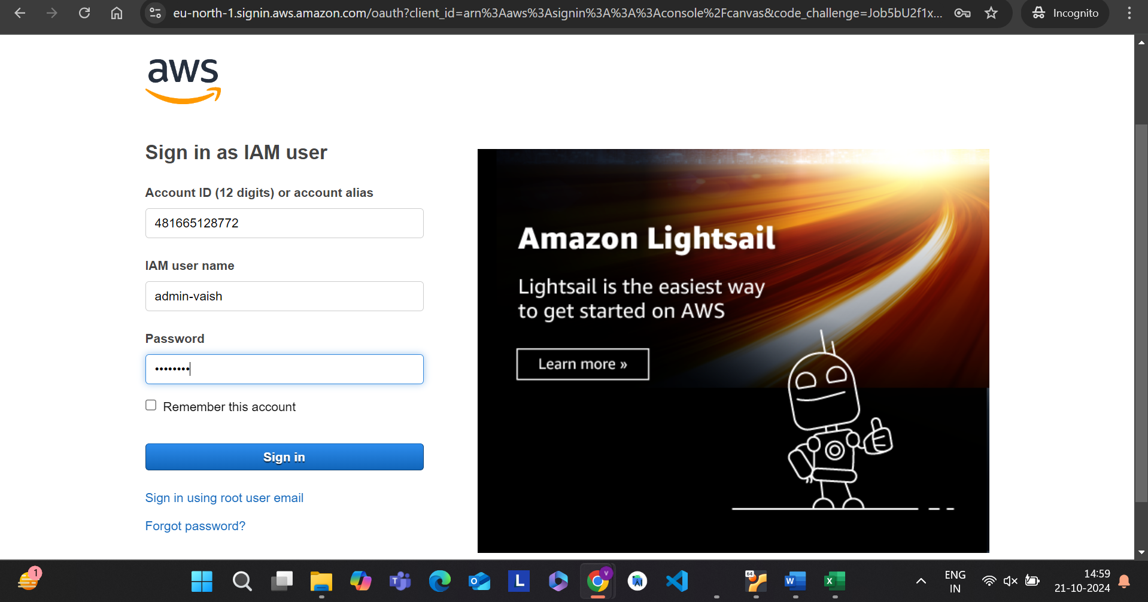

**Step 11: Search Ec2 instance and create an ec2 instance.**

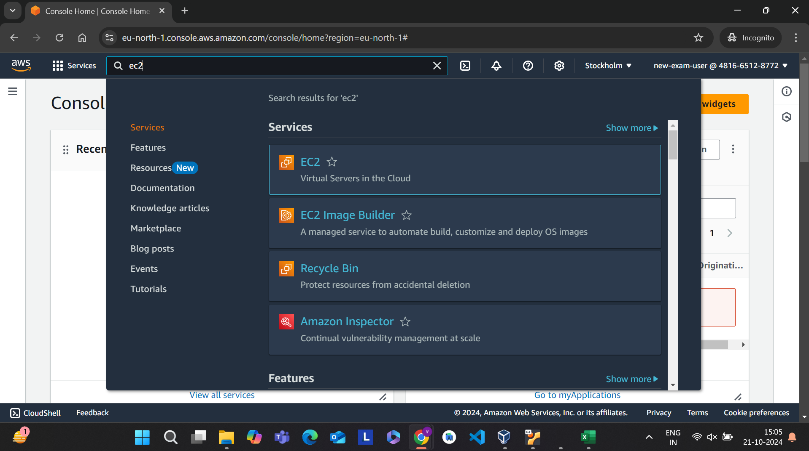

**Step 12:Click on launch instance**

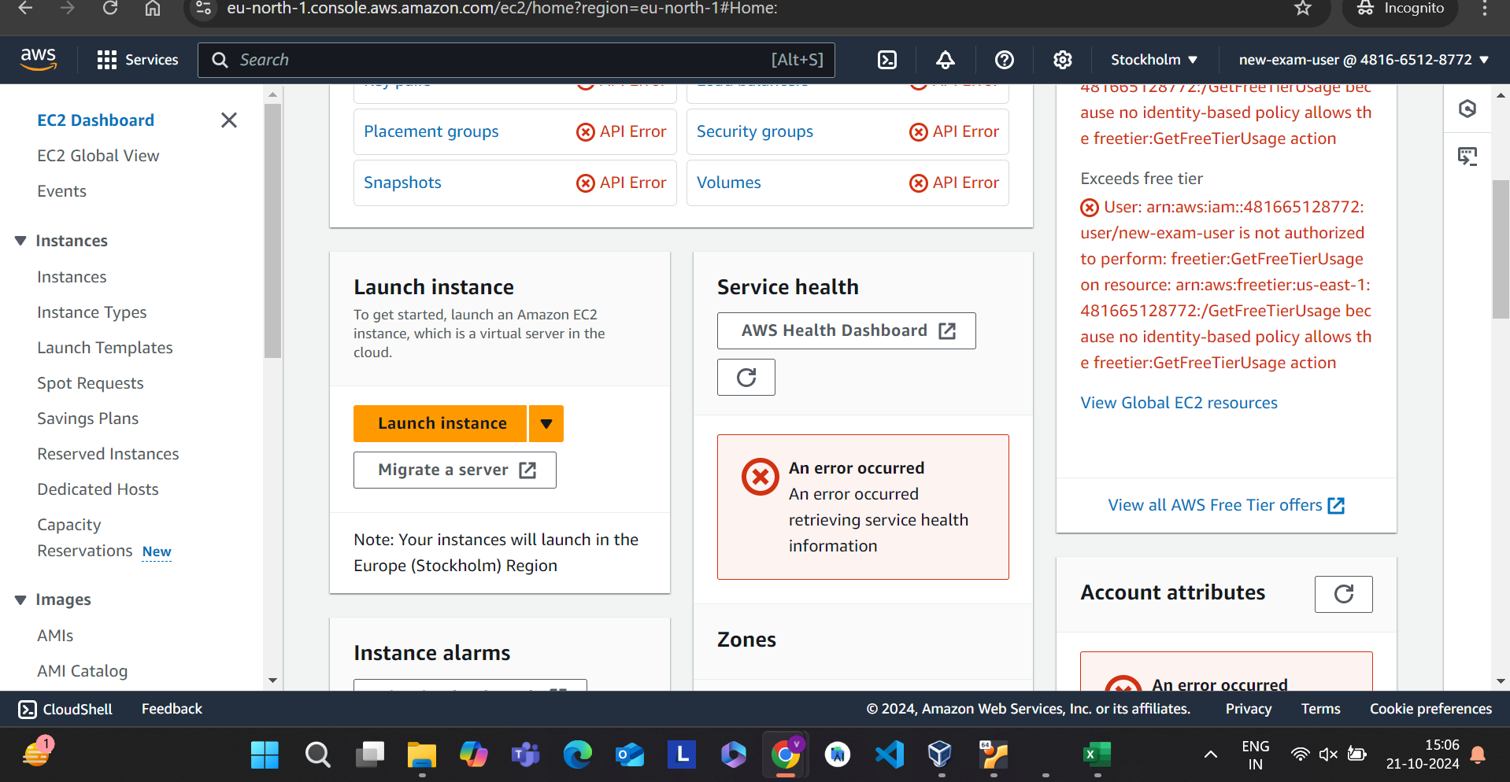

**Step 13:Give name to the instance and scroll down select application as aws and create key pair and click on launch instance.**

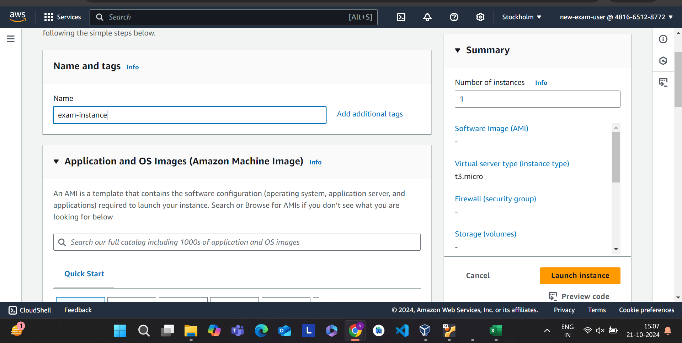

**Step 14:Then go to putty and enter the host name as public ip and then go to ssh->auth->credentials**

**Step1:Create a s3 bucket.**

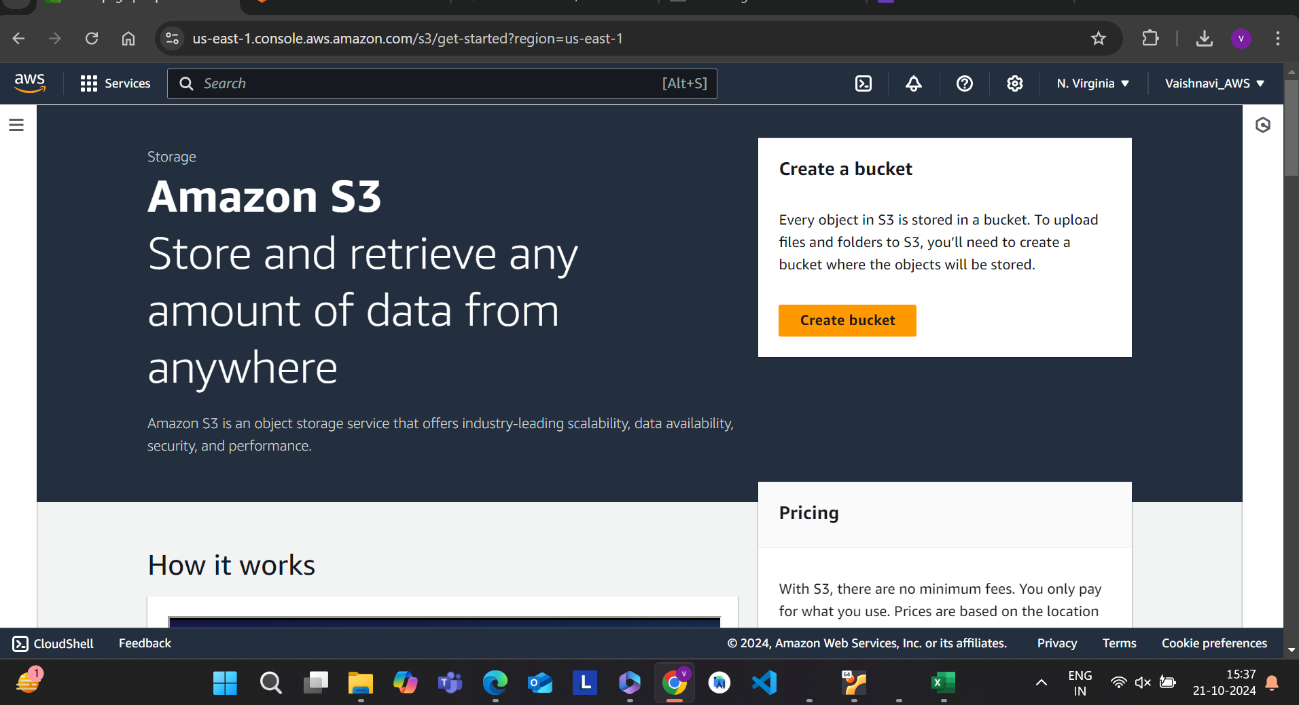

**Step2:enter bucket name and click on create bucket.**

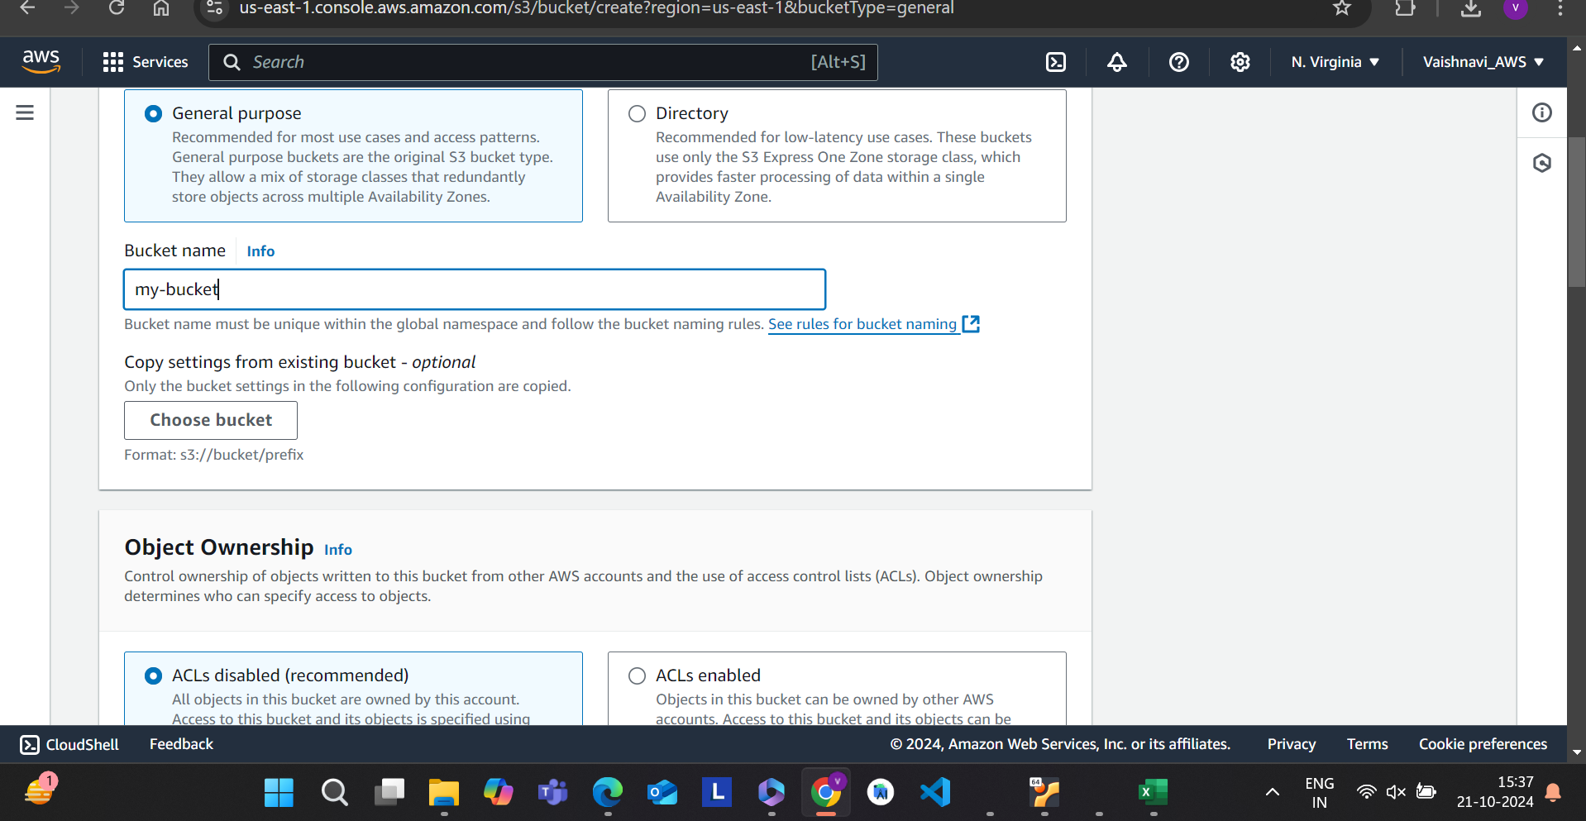

**Step3:upload the html file**

